Determining the Toxicity of Natural Products on Caenorhabditis elegans in the Search for New Anthelmintic Drug Leads

Ellen Chao,^{a,b} Lindsay Kate Caesar,ª Michael Warren Mullowney,ª Kathryn Evans,^{b} *Neil Kelleher,ª *Erik Andersen^{a,b}
ªChemistry of Life Processes Institute, Northwestern University, Evanston IL 60208
^{b}Department of Biological Sciences, Northwestern University, Evanston IL 60208
ellenchao2021@u.northwestern.edu
erik.andersen@northwestern.edu
n-kelleher@northwestern.edu

Abstract- This project aims to discover new molecules from microbial extracts that prove toxic to C. elegans yet harmless to mammals. First, fractionation of natural products produced by cultures of fungal and bacterial strains was performed and were analyzed using mass spectrometry. After a sufficient number of extract fractions were acquired and examined, high-throughput assays (HTA) were performed on C. elegans. One promising compound has been screened against C. elegans, and while the results seem to illustrate a sensitivity to the compound in traits such as mean time of flight (animal length), this may be an artifact of the assay because the brood size (animal fertility) seemed to increase with increasing drug concentration. The active ingredient in the toxin tested against C. elegans was found to be Antimycin A, a compound that induces mitochondrial stress and increases the reactive oxygen species (ROS) within the organism. This project is ongoing and thus, once more novel fractions are found, they will be purified and the structure of the bioactive compound will be elucidated using NMR, mass spectrometry, and HPLC techniques to correlate its anthelmintic properties with a chemical structure.

INTRODUCTION
Helminths are a class of parasitic worms that are one of the most common infectious agents known to man, affecting people in developing countries and the world’s livestock.¹ The very few compounds available to treat these infections are at risk of becoming obsolete because of rampant drug resistance, producing a huge medical and financial burden that threatens people, pets, and livestock.² Given that the roundworm Caenorhabditis elegans genome is homologous to these organisms of interest, C. elegans is an excellent model organism for mapping a drug resistance response to a gene cluster common in both C. elegans and other parasitic nematodes. Additionally, bacteria and fungi are known, prolific sources of novel natural product metabolites that have been used for decades as cancer, immunosuppressive, and anti-infective drug treatments.³ This project aims to discover new molecules from microbial extracts that prove toxic to C. elegans yet harmless to mammals. Research will include production, purification, and characterization of such compounds before each compound is tested for toxicity against C. elegans in a dose-response bioassay. The specific traits that will be used to measure the health of the worms are animal length, which corresponds to which stage of life the worm is in, and animal density, or how thick each individual is. These traits will be quantified and normalized for each population.

METHODS
Actinobacterial strains were inoculated in LB broth from cryopreserved stocks and shaken at 30 C before being cultured on a variety of agar media to obtain a pure culture; the plates were then incubated at 30 C. Two types of agar media were also prepared for the inoculation of various fungal strains from a frozen stock. The plates were incubated at 27 C for both a 1-week and a 2-week time period.
Both bacterial and fungal plates were then freeze-dried until solid, ground into a fine powder, extracted in methanol overnight, and then vacuum filtered. The bacterial strains were extracted using H₂O-CH₃OH-EtOAc (1:10:20) which were performed in a separatory funnel. The mixture was shaken by hand until layers were formed. If the phases were not separated, more water was added. The bottom layer was drawn off and both layers were evaporated to dryness. The solid product was weighed. The fungal strains were extracted using an equal volume of CH₃OH and hexanes. The mixture was shaken by hand and allowed to resettle. The bottom layer was drawn off and the top layer was evaporated to dryness. The resulting aqueous layer was further extracted with H₂O-CH₃OH-EtOAc (1:10:20) in a separatory funnel. The mixture was shaken by hand until layers formed, and if none appeared, more water was added for clearer separation. The top and bottom layers were drawn off and evaporated to dryness. Final solid products were weighed and recorded.
A previous dried fraction produced prior to this project was resuspended in 1 mL of DMSO to create a stock solution (33 mg/mL). This solution was diluted into eleven concentrations for a dose response, ranging from 0 mg/mL to 33 mg/mL. Animals were grown on 6 cm plates at 20 C on nematode growth medium agar (NGMA) spotted with OP50 bacteria. The two worm strains used were N2 and CB4856. The N2 strain is the extensively studied strain within the laboratory setting. The CB4856 strain is a wild Hawaiian isolate that is genetically divergent from the N2 strain. First, populations of each strain were grown on 6 cm plates for two generations before they were bleach-synchronized. Approximately 25 embryos from each strain were aliquoted into 96-well plates with a final volume of 50 uL of K medium. The following day, L1 animals were either fed HB101 bacteria fed at OD 10 or HB101 bacterial lysate at a final concentration of 5 mg/mL. The animals were grown for 48 hours at 20 C with constant shaking until the L4 stage was reached. The large-particle flow cytometer (COPAS BIOSORT; Union Biometrica, Holliston, MA) was used to sort three L4 larvae into 96-well plates that contained either HB101 bacteria at OD 20 or bacterial lysate at 10 mg/mL, K medium, 50 uM kanamycin, and either diluent (1% DMSO) or diluent and the fraction previously produced from natural extracts. The sorted animals were then allowed to grow for 96 hours at 20 C with constant shaking. In this time span, the sorted animals matured into adults and produced progeny which produced a total population of both parent and progeny in each well. Before fitness parameter assessment, the animals were treated with sodium azide (50 mM in M9) to straighten their bodies for more accurate parameter measurements. Photographs of each well were taken on the ImageXpress Nano (Molecular Devices, San Jose, CA) before traits such as brood size (n), animal length (time of flight, TOF), and animal density (extinction time, EXT) were measured using the BIOSORT. The phenotypic measurements obtained by the BIOSORT were analyzed using the easysorter package in RStudio.

- RESULTS

Two-hundred eighteen total fractions were generated from eight strains of fungi grown on two types of media and three strains of bacteria grown on six types of media. Fractions that yielded less than 10 mg were deprioritized, as there was likely not enough product to obtain a significant response in the C. elegans bioassay. The fifty fractions with a mass yield greater than 50 mg were prioritized for another dose response bioassay, which will be conducted sometime in the future.
The natural product fraction used for the high-throughput assay was cultured from the bacterial strain Streptomyces griseus. The fraction had previously been tested against human cancer cells and had proven lethal to their development. As this was a very crude fraction, many compounds are present, as confirmed by analysis through mass spectrometry, but the most notable may be antimycin A, which is a complex III inhibitor. Antimycin A disrupts the electron transport chain and decreases oxidative phosphorylation, causing an increase in reactive oxygen species (ROS) and oxidative stress.⁴
Using the high-throughput assay, the two strains of C. elegans that were tested displayed divergent phenotypic responses to increasing concentration of the compound. Mean animal length, median optical density, and normalized brood size were used as parameters of health, as a longer length, higher density, and more fertile animal indicated a healthier organism. The N2 strain seemed to be more resistant to the compound at higher concentrations because the strain displayed greater animal length and optical density than the CB4856 animals. Across both strains, animal length and optical density showed an inverse relationship to concentrations of the compound; the animals seemed to be performing worse as the concentration increased. However, an interesting relationship was also observed between the brood size, or animal fertility, and compound concentration. Both strains produced more progeny at the maximum drug condition than at a no drug condition as verified by the photographs taken before scoring. This signifies that the compound seems to be increasing fertility while inhibiting the growth of the animal.
Antimycin A may be responsible for these effects, as previous research has shown that mild inhibition of mitochondrial respiration can extend the lifespan of organisms such as yeast, worms, flies, and mice.⁴ The mechanism behind this behavior may be that increased ROS increase the transcriptional activity of hypoxia-inducible factor-1 (HIF-1), which is a homeostatic protein complex that may be increasing the lifespan of the organism. This increased lifespan may allow the animals to produce more progeny in a given time, which would explain the observed results.

CONCLUSION
Here we cultured actinobacterial and fungal strains under various media conditions for both one-week and two-week periods. Each strain was extracted into three fractions of differing polarity and evaporated to dryness, which resulted in two-hundred eighteen total fractions. The fifty fractions with a mass yield greater than 50 mg were prioritized for another dose-response bioassay, which will be conducted sometime in the future. The rest were deprioritized, as not enough product was obtained.
A natural product fraction produced previously in the Kelleher group was tested in a dose-response bioassay against two strains of C. elegans: CB4856 and N2. Phenotypic traits such as animal length (mean time of flight) and fertility (normalized brood size) were measured to assess the health of the animals. Both strains showed a trend of decreasing animal length with an increasing fertility as the dose of the toxin increased. This may have been due to the active ingredient of Antimycin A, which is a mitochondrial inhibitor that induces oxidative stress. The presence of this compound was verified in the fraction using mass spectrometry.
Future work will include determining the toxicity of the remaining extract fractions using the computational framework described above and elucidating the structure of compounds that prove toxic through proton NMR and mass spectrometry.

REFERENCES

[1] Hotez, Peter J., et al. “Helminth infections: the great neglected tropical diseases.” The Journal of Clinical Investigation, American Society for Clinical Investigation. 1 Apr. 2008, www.ncbi.nlm.nih.gov/pmc/articles/PMC2276811

[2] Charlier, Johannes, et al. “Decision making on helminths in cattle: diagnostics, economics, and human behavior.” Irish Veterinary Journal, BioMed Central, 27 Sept. 2016, www.ncbi.nlm.nih.gov/pmc/articles/PMC5039886

[3] Newman, David J, and Gordon M Cragg. “Natural Products as Sources of New Drugs from 1981 to 2014.” Journal of Natural Products, U.S. National Library of Medicine, 25 Mar. 2016, www.ncbi.nlm.nih.gov/pubmed/26852623.

[4] Ishiguro, Hiroyuki, et al. “Enhancement of oxidative damage to cultured cells and Caenorhabditis elegans by mitochondrial electron transport inhibitors.” Life, IUBMB. 1 Apr. 2001, https://iubmb.onlinelibrary.wiley.com/doi/abs/10.1080/152165401753311816

ACKNOWLEDGEMENTS

I would like to thank the members of the Andersen Laboratory and Kelleher Laboratory for their indispensable guidance and mentorship. This research was made possible by the Chemistry of Life Processes Institute Lambert Fellowship.

FIGURES AND DATA
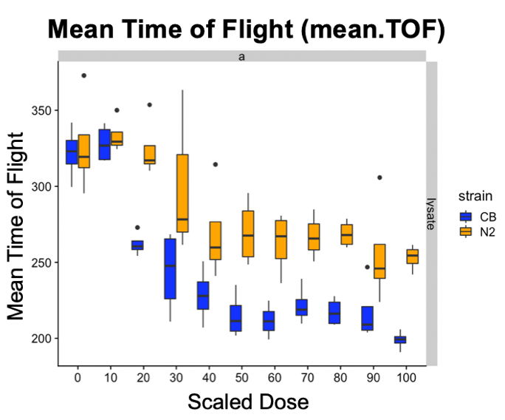
Figure 1: A phenotypic bioassay was performed on two strains of C. elegans, N2 which is depicted in orange and CB4856 which is depicted in blue. The trait of mean time of flight was analyzed as it was a correlate to the mean length of the animal, which illustrates how healthy the animal is. The longer the mean length/time of flight, the healthier the animal. An inverse relationship for both strains can be seen here between the phenotypic trait and the scaled dose.

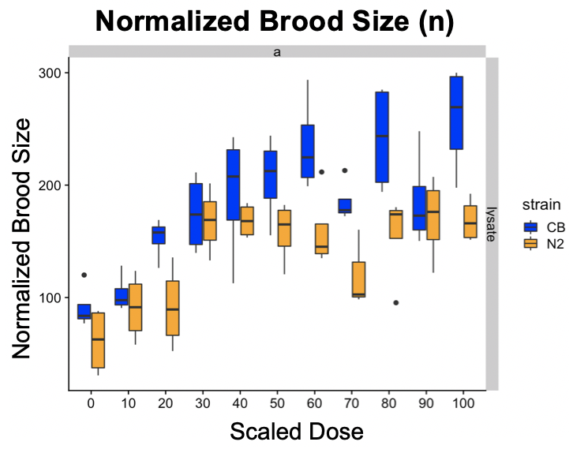
Figure 2: The bioassay also measured the fertility of each population of animals using the trait of normalized brood size, which describes how much progeny each single organism produces. Both strains seem to be increasingly fertile as the dosage of the toxin increases, with the CB4856 strain producing more progeny than the N2 strain.

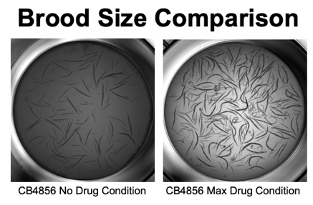
Figure 3: To verify the effects of the toxin on brood size, microscopy images were taken. Above are a sample of CB4856 animals taken at the two extremes of no drug and maximum drug conditions. It can clearly be seen that there are more animals in the maximum drug condition, which is internally consistent with the bioassay data.

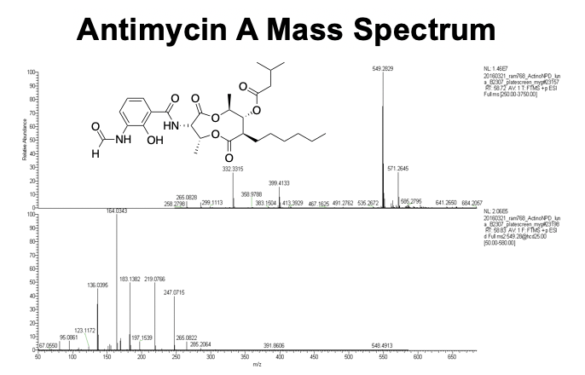
Figure 4: A mass spectrum of the compound was taken, and its parent and ionic fragment peaks reveal that the main, perhaps active, ingredient in the fraction was Antimycin A, whose structure is also shown above.

