Humans Exploit the Trade-Off Between Mediolateral Stability and Maneuverability During Walking: Data Repository

Summary Data:
A file containing participant anthropometric data, summary data, and analyzed trial data can be found in StabilityAdaptationsToManeuverAndResistPerturbations_Data.xlsx.
List of Abbreviations:
RT – Maneuver Reaction Time
MOS – Minimum Lateral Margin of Stability
FP_R – Foot Placement Error for the Right foot
FP_L – Foot Placement Error for the Left foot
FP_RS – Foot Placement Error for the Right foot for Straight Trials
FP_RV – Foot Placement Error for the Right foot for Target Shift Trials
FP_LS – Foot Placement Error for the Left foot for Straight Trials
FP_LV – Foot Placement Error for the Left foot for Target Shift Trials
Data:
- Participant Data
The participant data tab contains participant ID numbers and a summary of anthropometric measures like sex, age (in years), height (in m), and weight (in kg). It also contains leg length (in m) calculated as the distance between the greater trochanter from the bottom of the foot. The self-reported dominant leg is also recorded and was defined as the leg the participant would use for a task like drawing in the sand with their foot or kicking a ball.

- Summary Data
The summary data tab contains the average value for each participant in both environments (Baseline and Perturbed) for maneuver reaction time, minimum margin of stability, and foot placement error for right and left foot in straight and target shift trials.

- Trial Data
The trial data tab contains individual null force trials for each participant in both environments (Baseline and Perturbed) for maneuver reaction time, minimum margin of stability, and foot placement error for right and left foot. The type of trial is indicated by Trial (Straight or Maneuver) and Environment (Baseline or Perturbed). The data are not in any particular order and variable data from each category does not necessarily correspond with other categories in the same row other than participant ID, group and environment. NaN values were assigned when there were marker drops and insufficient data for those metrics to be calculated. Dashes (-) are assigned to metrics that were not calculated for a certain type of trial. For example, for a Straight trial, reaction time was not calculated and is represented by a dash (similarly, minimum MOS for manoeuvre trials).
One participant (ID = 2) got 15 extra straight null force trials in the complex field due to a protocoling error. Therefore, they have 15 extra data points for the minimum lateral margin of stability and foot placement error in straight trials, which were used to calculate the averages in the summary data.

Raw Data:
Raw data are provided for all 24 participants in a MATLAB data file named StabilityAdaptationsToManeuverAndResistPerturbations_RawData.mat. Participants are labelled p1 to p24 and data for each participant are stored in an individual structure in the file. The first point of all per-trial data is at the time of the start signal and the last point are at the time of the stop signal.

Data for each participant:
- P – Participant Number
- Shift – Direction of Maneuver
Participants 1 to 12 experienced lateral maneuvers, while participants 13 to 24 experienced medial maneuvers. The direction of maneuver is given as ‘Lateral’ or ‘Medial’.
- Protocol – List of type of trial
The protocol for each participant is expressed in two columns where the first refers to the type of forces applied and the second refers to whether it was a straight or maneuver trial. For column 1, ‘Null’ refers to a null force trial. For column 2, ‘Null’ refers to a straight trial, while ‘Visual R’ refers to a lateral maneuver and ‘Visual L’ refers to a medial maneuver.
- VisDis_ON – Time of Target Shift
- COM – Center of Mass
Each cell within the COM data contains a 3-column array corresponding to each trial in the protocol. Column 1 contains fore-aft position data, column 2 contains mediolateral position data, and column 3 contains data of the height of the center of mass. All data are global coordinates with reference to the lab origin.
- Foot Markers:
Each cell within the foot marker data contains a 5-column array corresponding to each trial in the protocol. Column 1 contains fore-aft position data, column 2 contains mediolateral position data, and column 3 contains data of the height of the center of mass. All data are global coordinates with reference to the lab origin.
  - L2Met – Left Foot 2nd Metatarsal Marker
  - L5Met – Left Foot 5th Metatarsal Marker
  - LCal – Left Foot Calcaneous Marker
  - R2Met – Right Foot 2nd Metatarsal Marker
  - R5Met – Right Foot 5th Metatarsal Marker
  - RCal – Right Foot Calcaneous Marker
- Gait Event Data:
  - LTO – Left Foot Toe-Off Time
  - LTO_frame – Left Foot Toe-Off Frame
  - LHS – Left Foot Heel-Strike Time
  - LHS_frame – Left Foot Heel-Strike Frame
  - RTO – Right Foot Toe-Off Time
  - RTO_frame – Right Foot Toe-Off Frame
  - RHS – Right Foot Heel-Strike Time
  - RHS_frame – Right Foot Heel-Strike Frame
- Location of Targets:
Target locations are expressed using 7 points, each containing the fore-aft position, mediolateral position and the height. The labels of each point are described in Fig 1.
  - Straight_targetloc – Location of Target for Straight Trials
  - Shifted_targetloc – Location of Target for Maneuver Trials
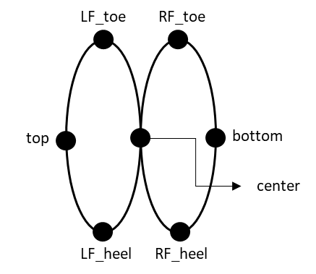
Fig 1. Points in Target Locations
Representation of a target with the top of the figure being the foremost of the target.

